HSE Response in relation to Action 2.1.14 November 2022
This action requires the HSE to:
Improve the availability of Opioid Substitution Treatments (OSTs).
And was to be achieved by - Examining potential mechanisms to increase access to OSTs such as the expansion of GP prescribing, nurse-led prescribing and the provision of OSTs in community-based settings and homeless services.
Over the last 3 years and in response to the COVID-19 Pandemic, the HSE had to directly address this action in order to promote the safety of individuals who were opioid dependent and at potential risk of contracting SARS CoV 2 and suffering morbidity and mortality. A research paper on the HSE Addiction Services response during the COVID-19 pandemic highlights many of the adaptations that occurred to meet this action (1). To access individuals into treatment and to promote safety to this cohort of individuals, existing Waiting Lists had to be addressed and reduced significantly. In order to achieve this, the HSE implemented a number of innovative changes to the delivery of care. These included:
- Clinical Guidelines on the rapid induction of clients to treatment were developed and modified in response to the ongoing pandemic
- Amendments to the Misuse of Drugs regulations to allow for the electronic transfer via Healthmail between GPs and Pharmacies to reduce waiting times were introduced and remain in place today.
- Recent discussions with the Controlled Drugs and Pharmacy Unit in the Department of Health have taken place in relation to the continuation of the Emergency Supply of controlled drugs (for no more than 5 days), including those involved in the provision of Opioid Substitution/Agonist Treatment (OST/OAT), on a permanent basis. The nature of OST/OAT in this country means that the pharmacist has a unique relationship with the patient, which would allow them to make such a decision in the best interests of the patient. There is a close working relationship between the pharmacist and the prescribing doctor that facilitates communication to allow for the safe, appropriate and necessary continuation of treatment to occur.
- Availability of OST/OAT was widened extensively and additional homeless settings were able to engage people on OST/OAT to ensure appropriate care.
- In recognition of the difficulties some individuals may have in accessing care, virtual clinics for prescribing GPs were established. What this demonstrated was the fact that this model increases access to OST/OAT, reduces waiting times and minimises barriers to service (2).
- A particular emphasis was placed on the provision of buprenorphine/naloxone (suboxone) as a medication to be used in OST/OAT. This was due to the easier induction phase and an increased safety profile in overdose, if it were to occur. This has resulted in a significant increase in the number of people receiving this medication and an increase in GPs prescribing the medication.

As a result of these innovations and changes, the HSE Addiction services and community level 1 and level 2 GPs are now providing OST/OAT to almost 1000 more individuals than at the end of January 2020 as can be seen in the table below
 | Jan 2020 | October 2023
Methadone | 10,233 | 10,774
Buprenorphine/Naloxone | 262 | 706
Total | 10,495 | 11480

The number of GPs prescribing buprenorphine-based products has increased from 37 at the end of January 2020 to 61 now. This increase is indication of the expansion of GP prescribing as outlined in action 2.1.14.
To determine whether these new changes and new guidelines should be retained post pandemic, we conducted a National Delphi study in conjunction with the RCSI to obtain consensus recommendations for OST/OAT following the introduction of emergency clinical guidelines in Ireland during the COVID-19 Pandemic. The study produced 16 consensus recommendations, none of which identified Nurse Prescribing as a potential mechanism to expand OST/OAT provision (3). The Delphi study drew together a multidisciplinary group of clinicians who were directly working in OST/OAT services in conjunction with people who were in receipt of OST/OAT and key workers. There was representation from specialist addiction services, primary care, homeless services, prison services and service users. This research examined the potential mechanisms to increase OST/OAT provision in the community and looked at all aspects of the current situation as per action 2.1.14 in the National Strategy. The 16 consensus recommendations are as follows:

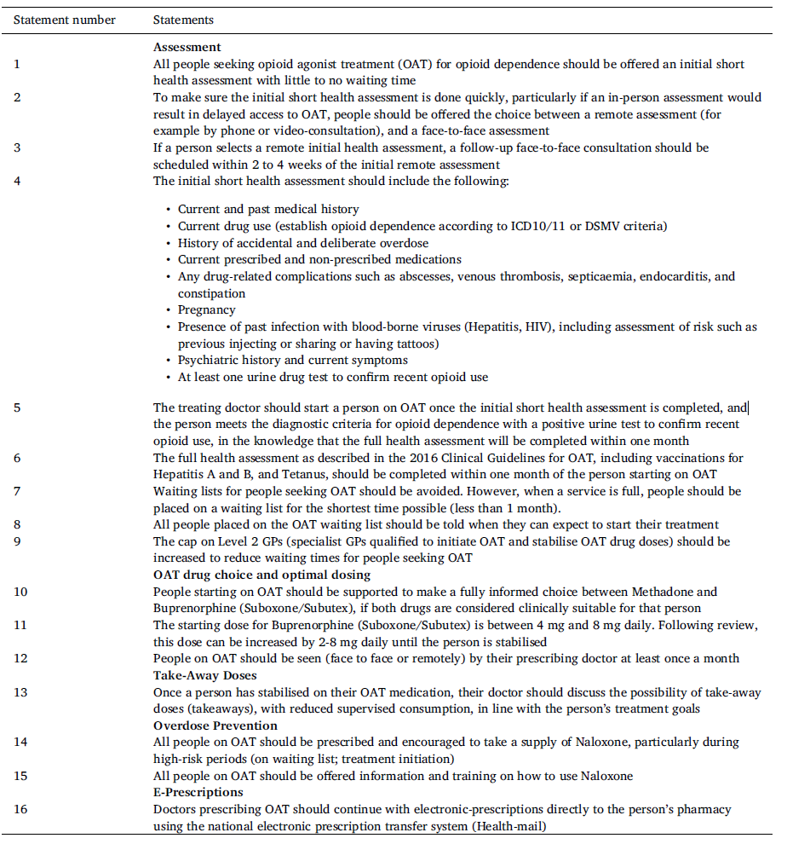

These recommendations, based on a National Delphi research study, published in the International Journal of Drug Policy in 2022 provide a template for ongoing work on OST/OAT in Ireland. Nurse Prescribing of OST/OAT as stated above was not identified in the study as a potential mechanism to progress services post pandemic.
Over the past decade, trends in drug misuse have changed significantly with now only 3% of all opioid users nationally under the age of 24 (4). Individuals presenting to services are increasingly more likely to present with polysubstance abuse (cocaine, alcohol, benzodiazepines, cannabis etc).
Given the high level of psychiatric comorbidity reported among crack cocaine users, it may be more appropriate for advocates of nurse prescribing in the addiction field to focus on developing prescribing for this cohort in addition to developing benzodiazepine withdrawal regimens or alcohol withdrawal regimens given the numbers of people presenting to services with those problems.
The majority of Opioid users in Ireland (73%) are aged between 35 and 65 (4). This aging population is more susceptible to infection, overdose and suicide and present with higher rates of degenerative disorders, circulatory and respiratory problems, diabetes, hepatitis and liver cirrhosis than their drug using peers .This population therefore requires an accessible collaborative approach, within which, GPs are ideally positioned to provide comprehensive care.
In Ireland, training for GPs is extensive to gain the competencies required for OST/OAT Prescribing and this is co-ordinated by the Substance Misuse Programme in the Irish College of General Practitioners. The ultimate aim is to have an individual receiving their OST/OAT as part of routine care delivered by their GP. The introduction of nurse prescribing of OST may delay or prevent this from happening.
In addition, nursing remains a key area within HSE Addiction services and many of the initiatives that have been developed or are developing currently rely heavily on nursing staff. Challenges in recruitment of nursing staff have resulted in additional pressures on nurses to deliver much needed interventions for this changing, complex cohort. It is vital therefore, that nurse Practice development initiatives accurately respond to the needs of the service user.

Prof. Eamon Keenan
Clinical Professor in Addiction Studies, Department of Public Health and Primary Care, TCD
National Clinical Lead HSE Addiction Services

References
- Response of tertiary addictions services to opioid dependence during the COVI-19 pandemic
Hennigan K, Corrigan N, Killeen N, Scully M, Keenan E.
Ir J Psychol Med. 2021 Dec;38(4):301-306. doi: 10.1017/ipm.2021.8. Epub 2021 Feb 4.

- A national model of remote care for assessing and providing opioid agonist treatment during the COVID-19 pandemic: a report
Crowley D, Delargy I.
Harm Reduct J. 2020 Jul 17;17(1):49. doi: 10.1186/s12954-020-00394-z.

- Consensus recommendations for opioid agonist treatment following the introduction of emergency clinical guidelines in Ireland during the COVID-19 pandemic: A national Delphi study
Durand L, Keenan E, Boland F, Harnedy N, Delargy Í, Scully M, Mayock P, Ebbitt W, Vázquez MO, Corrigan N, Killeen N, Pate M, Byrne P, Cousins G.
Int J Drug Policy. 2022 Aug;106:103768. doi: 10.1016/j.drugpo.2022.103768. Epub 2022 Jun 16.
4. Hanrahan MT, Millar SR, Phillips KP, Reed TE, Mongan D and Perry IJ (2022) Problematic opioid use in Ireland, 2015–2019. Dublin: Health Research Board. https://www.drugsandalcohol.ie/35856

